YOLOv8-Based Multi-Class Detection of Coffee Bean Defects and Contaminants for Automated Quality Grading

  *Corresponding Author | ABSTRACT  The quality of coffee beans is a crucial factor in determining export value and compliance with international standards set by the International Coffee Organization. Traditional manual sorting methods are time-consuming, labor-intensive, and prone to human subjectivity. This study presents an automated coffee bean quality grading system based on the YOLOv8s (You Only Look Once version 8 small) to identify physical defects and contaminants from static images. A dataset comprising 2,000 annotated images with 20 defect and contaminant classes was developed according to ICO and Standar Nasional Indonesia. The data were partitioned into training, validation, and testing sets using a 70:20:10 ratio. Transfer learning was employed using pre-trained YOLOv8s weights, and data augmentation techniques were applied to enhance model generalization. Experimental results demonstrated that the proposed model achieved a mean Average Precision at 0.5 (mAP@0.5) of 0.75, with precision of 0.76 and recall of 0.75. The model performed exceptionally well in detecting distinct classes such as normal beans, large husk fragments, stones, and twigs, while facing challenges in differentiating visually similar defect categories, particularly variants of black beans and sour beans. The trained model was integrated into a web-based application using FastAPI, enabling automatic detection of defects and computation of the total defect score for quality grading based on International Coffee Organization and Standar Nasional Indonesia 01-2907-2008 standards. This study offers a practical and scalable solution for objective coffee bean quality assessment, significantly reducing reliance on manual inspection while improving consistency and efficiency in the grading process.
Article History:
Submitted: xx
Accepted: xx

Published: xx

Keywords:
Coffee, YOLOv8, Detection, Grading, Vision
The Journal is licensed under a Creative Commons Attribution-NonCommercial 4.0 International (CC BY-NC 4.0).

INTRODUCTION
Coffee is a major plantation commodity with significant economic value in the global market, with Indonesia ranking as the fourth-largest coffee producer in the world (www.kompas.com, 2025). The quality of coffee beans is the main determining factor in meeting international export standards and maintaining the national coffee reputation. The quality standards set by the International Coffee Organization (ICO) and Specialty Coffee Association emphasize strict limits on physical defects. For specialty coffee, the number of defects should not exceed 5 full defects per 350 g sample(International Coffee Organization, 2024). Excessive physical defects or foreign contaminants can significantly reduce the selling value and risk market rejection(Adiwijaya, Sarno, & Wijaya, 2024; Gope, Fukai, Ruhad, & Barman, 2024).
Currently, the quality inspection and defect sorting process is mostly done manually through a method known as the double picker. This process relies heavily on the direct observation and vision of workers to inspect samples of coffee beans. Although it has become a common standard, this manual method has significant weaknesses, including quality inconsistency due to worker subjectivity, slow assessment time, and susceptibility to eye fatigue (Sirappa, Heryanto, & Silitonga, 2024).
The development of computer vision and deep learning, particularly the YOLOv8 algorithm, offers a breakthrough in automated quality control. While YOLOv8 has been successfully used for the classification of oranges and tomatoes (Adhi Prasetya et al., 2024)(Siwaka, Panjaitan, & Yacoub, 2025), furthermore, YOLOv8 has also proven highly reliable in detecting defects in the textile industry and classifying types of garbage (Alam et al., 2025)(Suwela & Hedriyadi, 2025). However, its implementation on coffee beans presents its own challenges due to the extremely subtle visual differences between defect types and the micro-physical dimensions of the beans, which range from 5 to 10 mm. YOLOv8 represents a state-of-the-art one-stage object detection model with improved accuracy and efficiency compared to previous YOLO versions, particularly in real-time applications; however, this study leverages its architectural efficiency to ensure high-precision detection in high-resolution static imagery. (Terven, Córdova-Esparza, & Romero-González, 2023).
Therefore, this study aims to implement and fine-tune the lightweight YOLOv8s architecture to accurately detect various types of physical defects (imperfections) and dirt (impurities) in static photos of coffee beans according to ICO and SNI standards. Furthermore, this study integrates the detection model into a web-based interface that automatically calculates the coffee quality grade based on the accumulated defect points found in the uploaded images, eliminating the subjectivity of manual human calculation.

LITERATURE REVIEW
Automated inspection systems for agricultural products have evolved significantly from conventional image processing and optical sensors to modern artificial intelligence and deep learning approaches (Musakkir & Sulastiyo, 2023). Deep learning architectures utilizing convolutional layers demonstrate superior performance in autonomous hierarchical feature extraction from visual inputs, making them suitable for various classification and detection tasks in the agricultural domain (Ariatmanto, Aris Setiyadi, Ema Utami, 2023)(Satya, Septian, Sarjono, Cahyanti, & Swedia, 2023). In the object detection domain, One-Stage Detectors such as YOLO are far superior to Two-Stage Detectors because they can localize bounding boxes and classify classes in a single evaluation stage. CNN-based architectures are capable of automatically extracting hierarchical features, making them highly effective for complex visual classification tasks.
Several previous studies have attempted to detect coffee defects. Michael et al. (2023) successfully classified coffee bean defects using transfer learning with the DenseNet201 CNN model, reaching an accuracy of 93% (Michael, Rusman, & History, 2023). Meanwhile, Rusman et al. (2023) used SVM to classify coffee ripeness levels (Rusman & Pasae, 2023). However, these studies focused only on single-image classification, not localizing multiple objects simultaneously. Other studies have used YOLOv8 for fruit quality classification, such as oranges with an mAP of 0.99 (Adhi Prasetya et al., 2024) and the level of ripeness of tomatoes based on their texture and color. (Siwaka et al., 2025). In contrast to these automated efforts, conventional manual sorting methods have major drawbacks such as lack of uniformity and fatigue, making them inefficient for large-scale agricultural production (Arifin, Insani, & Rasyid, 2023). The gap in this literature is the lack of optimized YOLOv8 architecture specifically focused on localizing 20 classes of coffee physical defects and contaminants and integrating them into an automated ICO grading calculation system based on static photographic inputs.

METHOD
This research was conducted using a structured methodology covering data acquisition, image preprocessing, model training, and the integration of an automatic grading system. The proposed system focuses on evaluating the quality of coffee beans from static photographic inputs rather than real-time video streams, ensuring high-precision macroscopic defect calculation.

Hardware and Software Environment
The image acquisition process utilized an iPhone 13 Mini smartphone equipped with a 12 Megapixel rear camera (f/1.8 aperture, 28mm wide lens) supported by Optical Image Stabilization (OIS) to ensure clear, close-range high-resolution images of the beans without motion blur. For the computational process, model training and evaluation were performed in a cloud-based environment using Google Colaboratory. The hardware specifications provided by the platform included an Intel Xeon CPU, 12 GB of RAM, and a powerful NVIDIA Tesla T4 GPU with 15 GB of VRAM, which significantly accelerated the deep learning training phase. The software stack included the Python programming language, PyTorch framework, and the Ultralytics YOLO library for model architecture implementation.

Data Collection and Preprocessing
A total of 2,000 static images of Arabica and Robusta coffee beans were collected offline in Takengon, Central Aceh. The photographs were taken using a top-down approach at a distance of 15-20 cm under natural lighting conditions to capture the micro-details of the beans (measuring 5-10 mm).

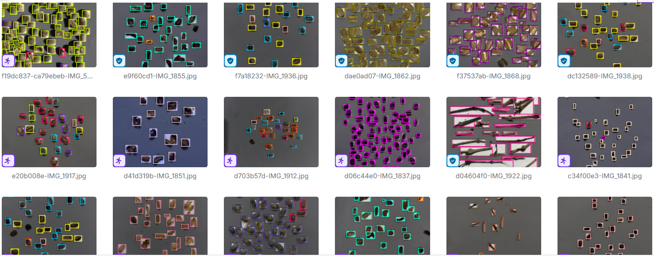
Fig. 1 Dataset Visualization
In the preprocessing stage, all images were standardized by resizing them to 640x640 pixels to match the YOLOv8 input requirements, followed by pixel normalization. Bounding box annotations were performed manually using the Label Studio software. The annotation process produced 3983 object labels categorized into 20 specific classes based on ICO standards. The dataset was then exported into the YOLO coordinate format.
To prevent model overfitting and enrich the visual features, data augmentation techniques were applied using the Roboflow platform. The augmentations included horizontal and vertical flips, as well as the addition of random noise up to 0.1% of pixels. This step effectively expanded the dataset to 2000 images. Finally, the dataset was randomly split into a training set (70% or 1,400 images), a validation set (20% or 400 images), and a testing set (10% or 200 images).

Model Architecture and Training
This study implemented the YOLOv8s (small) architecture, which provides an optimal balance between computational efficiency and high accuracy. The training process utilized a transfer learning approach, initializing the model with pre-trained weights from yolov8s.pt. The training configuration was set for 100 epochs using the default Ultralytics hyperparameters, with the input image size configured to 640x640 pixels. The model continuously adjusted its learning rate automatically to reach optimal convergence.

System Integration and Automatic Grading

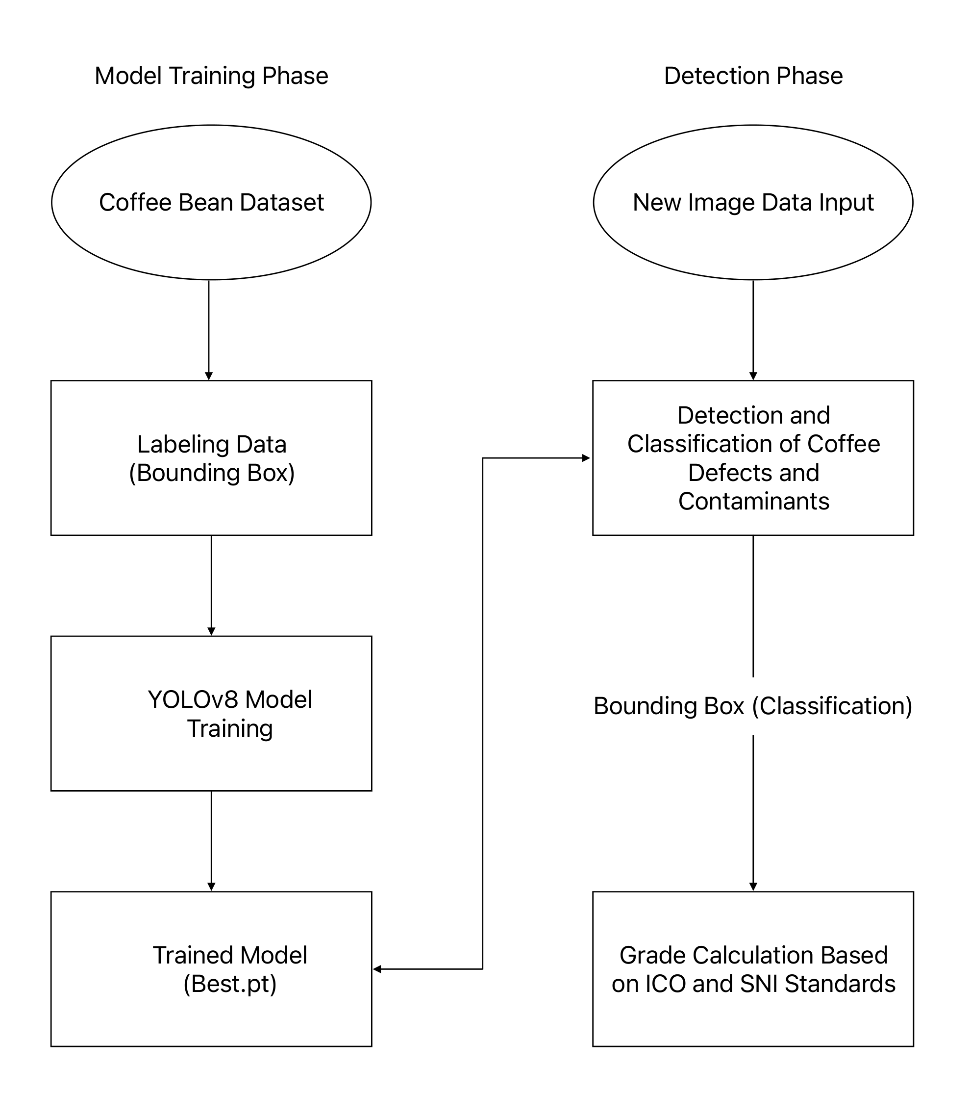
Fig. 2 System Schematic
Following the model evaluation, the best-performing weights (best.pt) were integrated into a web-based dashboard developed using the FastAPI framework and OpenCV library. The integrated system workflow is specifically designed to analyze static image uploads. Once a user uploads a photograph of coffee beans, the model detects the objects and projects bounding boxes over any identified defects or contaminants. Instead of physically sorting the beans, the system runs a background algorithm to map the detected classes to the standard ICO defect points. It then mathematically calculates the total accumulated defect points to determine and output the final quality grade of the coffee batch automatically.
To accurately determine the final grade of the coffee beans, the automated system relies on two fundamental standardization matrices. First, the system calculates the defect points based on a standardized defect value system. Each localized object, whether it is an imperfection or an impurity, is assigned a specific defect weight. The algorithm mathematically accumulates these points from the identified bounding boxes. The specific weight for each defect type is outlined in Table 1.
After the total defect score is computed from the detected objects, the final quality grade is determined by mapping the accumulated score to predefined classification thresholds. These thresholds define the acceptable defect ranges for each quality level according to the standard grading system. Table 1 presents the classification of coffee quality levels based on the total defect score intervals, which are used by the system to assign the final grade automatically.
Table 1 Quality Classification Based On Defect Value System
Quality | Total Defect Score
Quality 1 | Maximum 11
Quality 2 | 12 to 25
Quality 3 | 26 to 44
Quality 4a *) | 45 to 60
Quality 4b *) | 61 to 80
Quality 5 | 81 to 150
Quality 6 | 151 to 225

In addition to object detection and classification using the YOLOv8s model, the system is designed to automatically calculate the Total Defect Score based on the defect weighting system specified in SNI 01-2907-2008. Unlike the conventional manual method that evaluates defects based on a weighed sample of 300 grams, the proposed system calculates the defect score directly from the number of detected objects in the static image captured from the top-down view.
The system counts the number of bounding boxes detected for each defect class and multiplies it by the corresponding defect weight (defect point) as defined in SNI 01-2907-2008 (see Table 2). The calculation is formulated in Equation 1:

Equation 1.
Total Defect Score = Σ (Number of Detected Objects per Class × Defect Weight of the Class)

For example, if the system detects 10 whole black beans (weight = 1), the contribution is 10 × 1 = 10. If it detects 5 broken beans (weight = 1/5 or 0.2), the contribution is 5 × 0.2 = 1. Similarly, detecting one large twig or stone (weight = 5) contributes 1 × 5 = 5. All detected defect contributions are then summed automatically by the backend system.
After the Total Defect Score is computed from the static image, the system maps the accumulated score to the coffee quality classification according to SNI 01-2907-2008, as shown in Table 1. This classification aligns with international export requirements set by the International Coffee Organization (ICO). It should be noted that the grading in this system serves as an automated approximation based on image analysis.
To ensure standardized and objective defect evaluation, each detected object is assigned a specific defect weight based on the Indonesian National Standard (SNI 01-2907-2008). These weights represent the relative severity of each defect type and serve as the fundamental parameters in calculating the total defect score. Table 2 lists the defect categories along with their corresponding numerical weights, which are used in the computation process described in Equation 1.
Table 2 Coffee Bean Quality Classification SNI 01-2907-2008
No | Type of Disability | Defect Score
1 | Biji hitam penuh / Black beans | 1 (one)
2 | Biji hitam sebagian / Partly black bean | 1/2 (half)
3 | Biji hitam pecah / Broken black bean | 1/2 (half)
4 | Kopi gelondong / Husk coffee | 1 (one)
5 | Biji cokelat / Brown bean | 1/4 (a quarter)
6 | Kulit kopi (husk) ukuran besar / Large husk fragment | 1 (one)
7 | Kulit kopi (husk) ukuran sedang / Medium husk fragment | 1/2 (half)
8 | Kulit kopi (husk) ukuran kecil / Small husk fragment | 1/5 (one-fifth)
9 | Biji berkulit tanduk / Bean in fragment | 1/2 (half)
10 | Kulit tanduk ukuran besar / Large parchment fragment | 1/2 (half)
11 | Kulit tanduk ukuran sedang / Medium parchment fragment | 1/5 (one-fifth)
12 | Kulit tanduk ukuran kecil / Small parchment fragment | 1/10 (one-tenth)
13 | Biji pecah / Broken bean | 1/5 (one-fifth)
14 | Biji muda / Immature bean | 1/5 (one-fifth)
15 | Biji berlubang satu / Bean with one hole | 1/10 (one-tenth)
16 | Biji berlubang lebih dari satu / Bean with more than one hole | 1/5 (one-fifth)
17 | Biji bertutul-tutul (proses basah) / Spotted bean | 1/10 (one-tenth)
18 | Ranting, tanah, atau batu ukuran besar / Large stick/stone | 5 (five)
19 | Ranting, tanah, atau batu ukuran sedang / Medium stick/stone | 2 (two)
20 | Ranting, tanah, atau batu ukuran kecil / Small stick/stone | 1 (one)

Based on the defined defect classification and grading standards, the developed system is capable of automatically evaluating coffee bean quality by calculating the total defect score from detected objects. After establishing the system framework and dataset preparation, the next stage focuses on evaluating the performance of the trained YOLOv8s model.

The results of the training process and model evaluation are presented in the following section.

RESULT
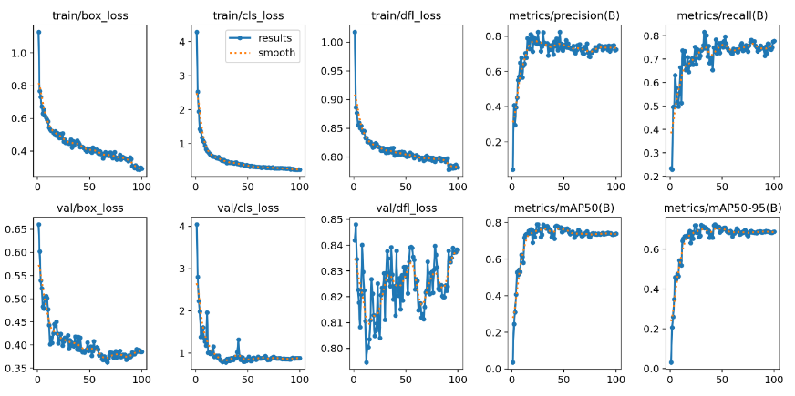
Fig. 3 Model Training Graph
Fig. 3 presents the training and validation curves of the YOLOv8s model over 100 epochs. The loss curves show good convergence, with both training and validation box loss, classification loss, and DFL loss decreasing consistently. The model achieved stable performance with a precision of 0.76, recall of 0.75, and mean Average Precision (mAP@0.5) of 0.75 on the test set. Although minor fluctuations were observed in the validation DFL loss during the later stages, there was no significant sign of overfitting.

Qualitative Detection Results

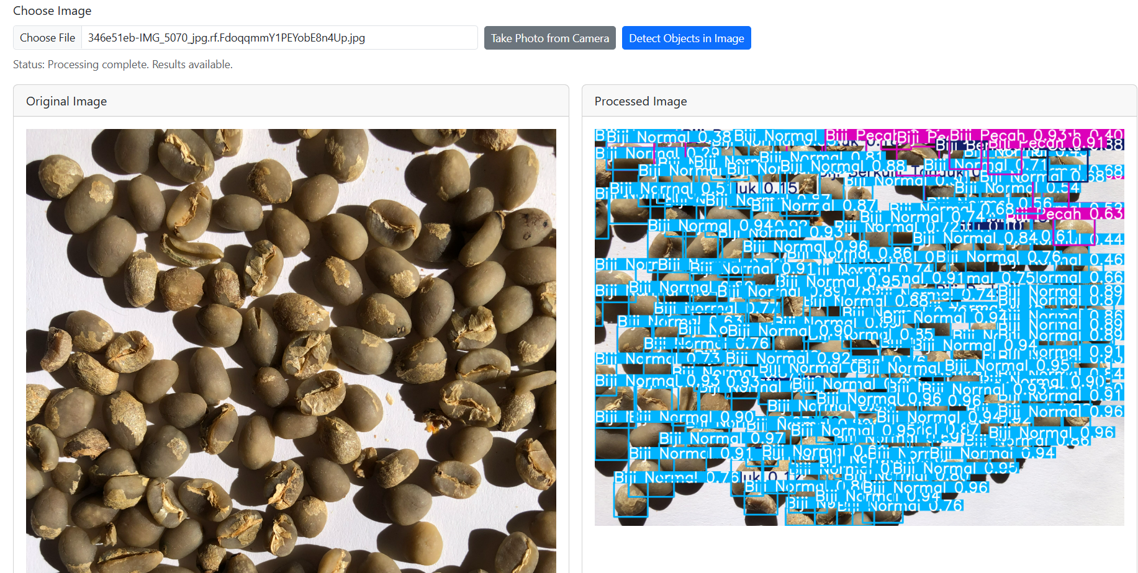
Fig. 4 Detection Visualization
Fig. 4 presents the qualitative detection results generated by the YOLOv8s model on a sample test image. The model demonstrates the ability to detect and localize multiple objects simultaneously using bounding boxes and class labels with associated confidence scores. The detected objects are associated with confidence scores generally above 0.7, indicating a relatively high level of prediction certainty across most classes. Qualitative visualization is commonly used to evaluate object detection performance by illustrating bounding box predictions and classification confidence (Gope et al., 2024). Most detected objects are correctly classified as “Biji Normal,” which aligns with the dominance of visually intact beans in the image. In addition, the model successfully identifies several defect classes such as “Biji Berlubang Satu,” “Biji Hitam Penuh,” and “Biji Muda,” indicating its capability to distinguish between multiple defect categories within a single frame.
The visualization also reveals that the model performs well in detecting objects with clear visual characteristics, particularly those with distinct shape or texture differences. However, some overlapping bounding boxes and dense label placements are observed due to the high number of objects in a single image. This suggests that while the model is capable of multi-object detection, this phenomenon is particularly evident in dense object scenarios, where overlapping bounding boxes and label congestion occur due to the high number of detected instances within a limited spatial area.
Furthermore, this limitation is primarily caused by high intra-class similarity and low inter-class variance among defect categories, particularly in beans with subtle color and texture variations, especially between beans with subtle color variations such as “Biji Cokelat” and other defect categories. This observation is consistent with the confusion matrix results, where similar classes exhibit overlapping predictions. Overall, the qualitative results confirm that the YOLOv8s model is capable of accurately localizing and classifying multiple coffee bean defects, while highlighting the inherent challenges in fine-grained classification tasks involving small objects and subtle visual differences.

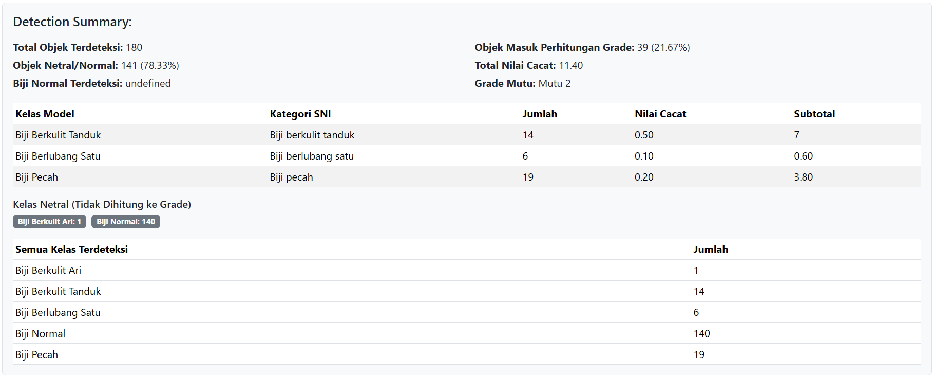
Fig. 5 Detection Summary
Fig. 5 illustrates the detection summary and automated grading output generated by the developed system. The system successfully processes the detection results and computes quantitative metrics, including the total number of detected objects, class distribution, total defect score, and final quality grade based on ICO and SNI standards. In this example, a total of 180 objects are detected, with 141 classified as normal beans and 39 categorized as defects contributing to the grading calculation.
The system calculates the total defect score by aggregating the weighted contributions of each detected defect class. For instance, defects such as “Biji Berkulit Tanduk,” “Biji Berlubang Satu,” and “Biji Pecah” are assigned different weights according to the predefined defect value system. The accumulated defect score of 11.40 places the sample within the “Mutu 2” / Quality 2 category, indicating moderate-quality coffee beans according to the applied grading standards.
Additionally, the summary provides a detailed breakdown of detected classes, including both graded defects and neutral classes that are excluded from scoring. This separation enhances the interpretability of the results and ensures transparency in the grading process. The integration of detection outputs with standardized scoring criteria demonstrates the practical capability of the system to perform end-to-end quality assessment.
Overall, the system not only detects defects but also translates these detections into meaningful quality metrics, reducing subjectivity and improving consistency compared to manual inspection methods.
Table 3 Performance Metrics of the Yolov8s Model
Class (Indonesia/English) | Precision | Recall | mAP@0.5
Biji Berkulit Ari/ Seeds with a Thin Shell | 1.00 | 1.00 | 1.00
Biji Berkulit Tanduk/ Horned Seeds | 1.00 | 1.00 | 1.00
Biji Berlubang Lebih dari satu/ Seeds with More Than One Hole | 0.60 | 0.73 | 0.66
Biji Berlubang Satu/ Single-Hole Seed | 0.58 | 0.68 | 0.63
Biji Cokelat/ Chocolate Finish | 0.48 | 0.52 | 0.50
Biji Hitam Pecah/ Cracked Black Seeds | 0.52 | 0.58 | 0.55
Biji Hitam Penuh/ Whole Black Seeds | 0.41 | 0.44 | 0.42
Biji Hitam Sebagian/ Partially Black Seeds | 0.00 | 0.00 | 0.00
Biji Muda/ Young Seeds | 0.72 | 0.81 | 0.76
Biji Normal/ Normal Seeds | 0.59 | 0.64 | 0.61
Biji Pecah/ Cracked Seeds | 0.82 | 0.88 | 0.85
Brown Yellow/ Sour Bean | 0.32 | 0.38 | 0.35
Kerikil/ Pebbles | 0.95 | 0.97 | 0.96
Kopi Gelondong/ Coffee Beans | 0.92 | 0.96 | 0.94
Kulit Kopi Ukuran Besar/ Large Size Coffee Bark | 0.88 | 0.92 | 0.90
Kulit Kopi Ukuran Kecil/ Small Size Coffee Bark | 0.62 | 0.70 | 0.66
Kulit Kopi Ukuran Sedang/ Medium Size Coffee Bark | 0.85 | 0.89 | 0.87
Kulit Tanduk Ukuran Besar/ Large Horn Skin | 0.90 | 0.94 | 0.92
Kulit Tanduk Ukuran Kecil/ Small Horn-Shaped Skin | 0.58 | 0.65 | 0.61
Kulit Tanduk Ukuran Sedang/ Medium-Sized Horn Skin | 0.82 | 0.87 | 0.84
Ranting Ukuran Besar/ Large Branches | 1.00 | 1.00 | 1.00
Ranting Ukuran Kecil/ Small Branches | 0.75 | 0.82 | 0.78
Ranting Ukuran Sedang/ Medium-Sized Branch | 0.88 | 0.93 | 0.90
Rata-rata (Mean) | 0.76 | 0.75 | 0.75

Table 3 summarizes the class-wise evaluation results of the YOLOv8s model, highlighting variations in detection performance across different defect categories. The results indicate that classes with distinctive visual characteristics achieve higher precision and recall, while visually similar defect classes tend to exhibit lower performance metrics.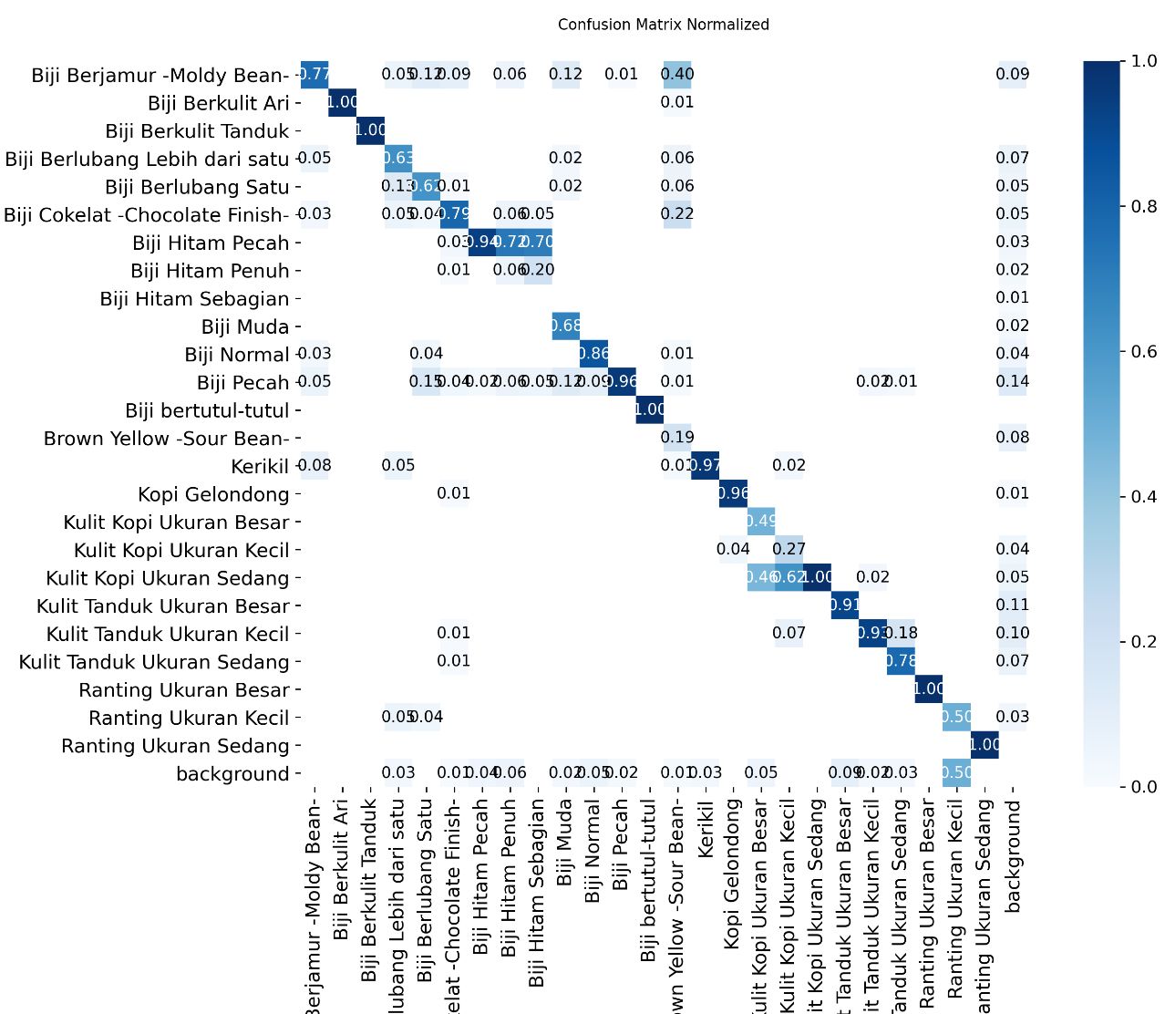
Figure 6 Normalized Confusion Matrix of YOLOv8s Model Across All Classes
Figure 6 presents the normalized confusion matrix of the YOLOv8s model across all classes. The diagonal values represent correct classifications, while off-diagonal values indicate misclassifications between classes. The results show that several classes, such as "Biji Berkulit Ari", "Biji Berkulit Tanduk", and "Ranting Ukuran Besar", achieve near-perfect classification performance, with values approaching 1.0 on the diagonal. This indicates that the model is highly effective in detecting objects with distinct visual characteristics.However, significant misclassification is observed among visually similar classes. For instance, "Biji Hitam Pecah" is frequently confused with "Biji Hitam Penuh", and "Biji Pecah" shows overlap with other defect classes. This confusion is likely caused by the similarity in color degradation and structural damage patterns among these classes.
Additionally, certain classes such as "Brown Yellow (Sour Bean)" and smaller-sized impurities exhibit lower diagonal values, indicating weaker detection performance. This suggests that the model struggles with subtle visual differences and small object sizes.Overall, the confusion matrix highlights that while the model performs well on distinct classes, its performance is limited when distinguishing fine-grained defects with similar visual features. Efficient inference performance is considered suitable for practical deployment in interactive computer vision systems (Xiao et al., 2023).

DISCUSSION
The YOLOv8s model achieved the highest detection performance on classes with distinct visual characteristics, such as “Biji Berkulit Ari”, “Biji Berkulit Tanduk”, “Ranting Ukuran Besar”, and “Kerikil”, reaching mAP@0.5 values approaching 1.00. In contrast, lower performance was recorded in visually similar defect categories, including black bean variants (“Biji Hitam Penuh”, “Biji Hitam Pecah”, “Biji Hitam Sebagian”), “Biji Cokelat”, and “Brown Yellow (Sour Bean)”. The normalized confusion matrix confirms frequent misclassifications among these classes, mainly due to subtle color degradation, structural similarities, small object size (5–10 mm), and top-down imaging conditions. This highlights that the main challenge lies in fine-grained classification rather than object localization.
Despite these limitations, the integration of the YOLOv8s model into a web-based grading system provides significant practical value. The proposed system not only detects multiple defect types but also automatically calculates defect scores and determines coffee quality grades according to ICO and SNI 01-2907-2008 standards. This approach effectively reduces subjectivity and improves consistency compared to the conventional double-picker manual sorting method.
Although the achieved mAP@0.5 of 0.75 is moderate, it remains competitive within the context of multi-class object detection involving a large number of categories and visually similar objects(Qi et al., 2023),(Hossain et al., 2025). The complexity of the task is further amplified by the small object size and subtle visual differences between defect categories. This study contributes by developing an end-to-end automated grading system that directly translates detected defects into standardized SNI quality scores, addressing a practical gap in the coffee industry where grading is still predominantly performed manually. Future work should focus on increasing dataset diversity, improving class balance, and applying more advanced augmentation techniques to enhance performance on visually similar defect categories.

CONCLUSION
This study successfully implemented the YOLOv8s algorithm to detect physical defects and contaminants in static photographs of coffee beans and to automatically calculate their quality grade based on International Coffee Organization (ICO) standards. The model achieved an average Mean Average Precision (mAP@0.5) of 0.75 across 20 classes, indicating a moderate but reliable performance for multi-class object detection in a complex visual domain.
The model demonstrates strong performance in detecting classes with distinct visual characteristics, such as "Biji Berkulit Ari", "Biji Berkulit Tanduk", and larger impurities (e.g., "Ranting Ukuran Besar" and "Kerikil"), achieving near-perfect detection accuracy. However, its performance decreases when distinguishing between visually similar defect classes, particularly among "Biji Hitam Penuh", "Biji Hitam Pecah", and "Biji Pecah", where misclassification frequently occurs.
A key limitation identified in this study is the model’s difficulty in fine-grained classification, as reflected in the confusion between "Biji Pecah" and "Biji Hitam" with a misclassification rate of approximately 0.20. This limitation is primarily caused by the high similarity in color degradation and structural damage patterns among these classes, combined with the small object size and top-down imaging perspective.
Despite these limitations, the integration of the detection model into a web-based grading system provides a practical and scalable solution for coffee quality assessment. The system enables automatic calculation of defect scores based on standardized ICO and SNI criteria, reducing reliance on manual inspection methods and improving consistency in quality control.
For future work, it is recommended to improve dataset diversity by incorporating more varied imaging conditions, such as different lighting, angles, and object scales. Additionally, applying targeted data augmentation and exploring higher-resolution imaging techniques may enhance the model’s ability to distinguish between visually similar defect classes.

ACKNOWLEDGMENT
The author would like to thank the Faculty of Engineering, Informatics Engineering Study Program, Universitas Malikussaleh. The highest appreciation is also expressed to all supervising lecturers who have provided valuable guidance, facilities, and continuous support during the development and completion of this research.

REFERENCES
Adhi Prasetya, I., Sukandiarsyah, F., Aryani Fitri, N., Adam, S., Studi Teknologi Informasi Politeknik Aisyiyah Pontianak Jl Ampera, P., Kalimantan Barat Indonesia, P., & Pontianak Jl Ahmad Yani, N. (2024). Klasifikasi kualitas buah jeruk menggunakan computer vision dengan arsitektur YOLO V8. Jurnal Pendidikan Informatika Dan Sains, 13(2), 187–201. https://doi.org/10.31571/SAINTEK.V13I2.8346
Adiwijaya, N. O., Sarno, R., & Wijaya, D. R. (2024). Real Time Detection of Coffee Bean Defects Using YOLO Method and SAHI (Slicing Aided Hyper Inference) Framework. 2024 Beyond Technology Summit on Informatics International Conference, BTS-I2C 2024, 286–291. https://doi.org/10.1109/BTS-I2C63534.2024.10941784
Alam, B. M. S., Noor, M. T., Momo, I. J., Mia, M. P., Ahammed, F., & Ali, M. N. Y. (2025). Fabric Finesse: Harnessing YOLOv8 for Enhanced Textile Detection. 2025 International Conference on Electrical, Computer and Communication Engineering, ECCE 2025. https://doi.org/10.1109/ECCE64574.2025.11013032
Ariatmanto, Aris Setiyadi, Ema Utami, D. (2023). Analisa Kemampuan Algoritma YOLOv8 Dalam Deteksi Objek Manusia Dengan Metode Modifikasi Arsitektur. J-SAKTI (Jurnal Sains Komputer Dan Informatika), 7(2), 891–901. Retrieved from http://tunasbangsa.ac.id/ejurnal/index.php/jsakti/article/view/694
Arifin, N., Insani, C. N., & Rasyid, M. R. (2023). Klasifikasi Tingkat Kematangan Buah Tomat menggunakan Computer Vision untuk Smart Agriculture. Jurnal SAINTIKOM (Jurnal Sains Manajemen Informatika Dan Komputer), 22(2), 509–516. https://doi.org/10.53513/JIS.V22I2.8387
Gope, H. L., Fukai, H., Ruhad, F. M., & Barman, S. (2024). Comparative analysis of YOLO models for green coffee bean detection and defect classification. Scientific Reports 2024 14:1, 14(1), 1–16. https://doi.org/10.1038/s41598-024-78598-7
Hossain, H. M., Nath, P., Mahi, M. N., Uddin, I., Eiste, I. J., Ratul, S. N. R., … Hossain, M. T. (2025). Evaluating YOLO Architectures: Implications for Real-Time Vehicle Detection in Urban Environments of Bangladesh. Retrieved from https://arxiv.org/pdf/2509.05652
International Coffee Organization. (2024). Existing Definitions of Specialty Coffee. Retrieved from https://ico.org/documents/cy2024-25/fgsc-3e-definitions-specialty-coffee.pdf
Michael, A., Rusman, J., & History, A. (2023). Klasifikasi Cacat Biji Kopi Menggunakan Metode Transfer Learning dengan Hyperparameter Tuning Gridsearch. Jurnal Teknologi Dan Manajemen Informatika, 9(1), 37–45. https://doi.org/10.26905/JTMI.V9I1.10035
Musakkir, A. F. R., & Sulastiyo, L. E. P. (2023). Sistem Sortir Buah Berbasis Internet of Things.
Qi, Z., Dong, R., Fan, G., Ge, Z., Zhang, X., Ma, K., & Yi, L. (2023). Contrast with Reconstruct: Contrastive 3D Representation Learning Guided by Generative Pretraining. Proceedings of Machine Learning Research, 202, 28223–28243. Retrieved from https://arxiv.org/pdf/2302.02318
Rusman, J., & Pasae, N. (2023). Prototype Sistem Penyortir Buah Kopi Arabika Berdasarkan Tingkat Kematangan Menggunakan Metode Support Vector Machine. Teknika, 12(1), 65–72. https://doi.org/10.34148/TEKNIKA.V12I1.602
Satya, L., Septian, M. R. D., Sarjono, M. W., Cahyanti, M., & Swedia, E. R. (2023). SISTEM PENDETEKSI PLAT NOMOR POLISI KENDARAAN DENGAN ARSITEKTUR YOLOV8. Sebatik, 27(2), 753–761. https://doi.org/10.46984/SEBATIK.V27I2.2374
Sirappa, M. P., Heryanto, R., & Silitonga, Y. R. (2024). Standardisasi Pengolahan Biji Kopi Berkualitas. Warta BSIP Perkebunan, 2(1), 18–25.
Siwaka, F. A., Panjaitan, S. D., & Yacoub, R. R. (2025). IMPLEMENTASI ALGORITMA DEEP LEARNING YOLOV8 PADA ALAT SORTIR KEMATANGAN BUAH TOMAT. Kohesi: Jurnal Sains Dan Teknologi, 7(11), 1–10. https://doi.org/10.2238/52EQV641
Suwela, N., & Hedriyadi, M. Z. (2025). DETEKSI JENIS SAMPAH MENGGUNAKAN METODE TRANSFER LEARNING YOLO-V8. Jurnal Sistem Informasi Dan Sains Teknologi, 7(1). https://doi.org/10.31326/SISTEK.V7I1.2125
Terven, J., Córdova-Esparza, D. M., & Romero-González, J. A. (2023). A Comprehensive Review of YOLO Architectures in Computer Vision: From YOLOv1 to YOLOv8 and YOLO-NAS. Machine Learning and Knowledge Extraction, 5(4), 1680–1716. https://doi.org/10.3390/make5040083
www.kompas.com. (2025). Berita BRMP Perkebunan - Tren 2025: Peluang dan Daya Saing Kopi. Retrieved November 13, 2025, from https://perkebunan.brmp.pertanian.go.id/berita/tren-2025-peluang-dan-daya-saing-kopi
Xiao, P., Xiao, M., Cai, N., Qiu, B., Zhou, S., & Wang, H. (2023). Adaptive Hybrid Framework for Multiscale Void Inspection of Chip Resistor Solder Joints. IEEE Transactions on Instrumentation and Measurement, 72. https://doi.org/10.1109/TIM.2023.3235435

